**Storyboard for Game Engines 2 Assignment.**

**James Gormley – C10720209**

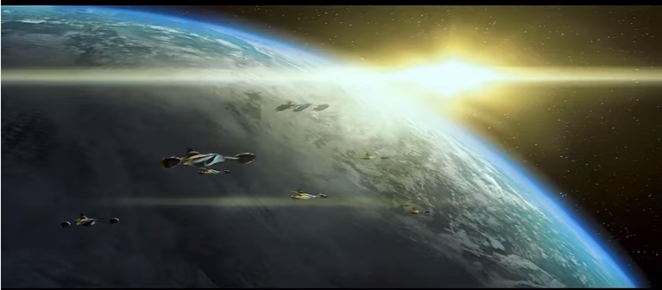

Number of Naboo Starfighters fly in loose formation (pursuing the lead ship) past the camera (some error built in to the offset in x, y and z to look natural). The camera turns to follow the first and view them all fly away.

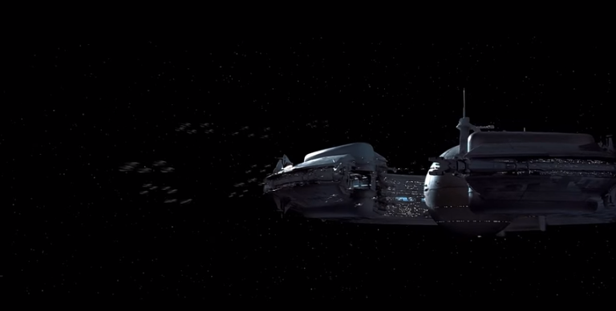

A large number of Trade Federation fighters leave the Droid Control Station to intercept. Again numerous lead ships with wingmen pursuing at an offset and in formation.

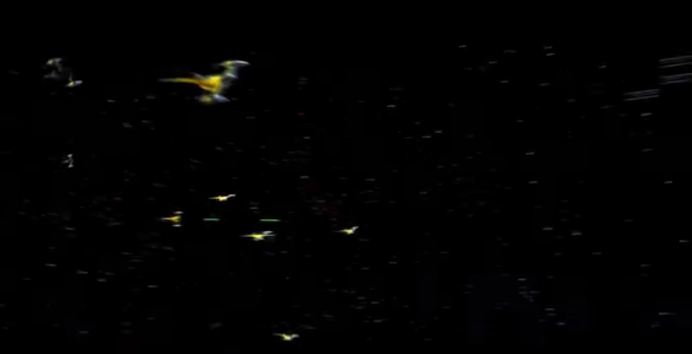

On meeting, the ships from both sides take evasive manoeuvres, accomplished with a combination of randomisation of some paths combined with fleeing and pursuing like behaviours. The ships also exchange blaster fire as the camera pans to include the Droid Control Ship in the shot.

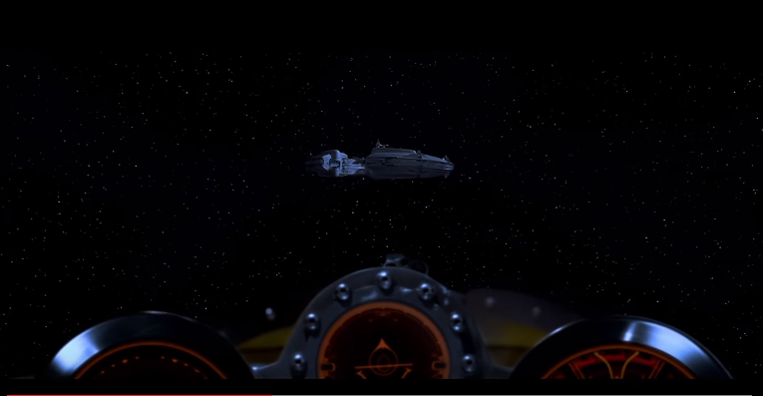

Cockpit view of Anakins fighter approaching the space station may be included if the model has a detailed cockpit to place the camera in. Some screen shake could add to this shot significantly.

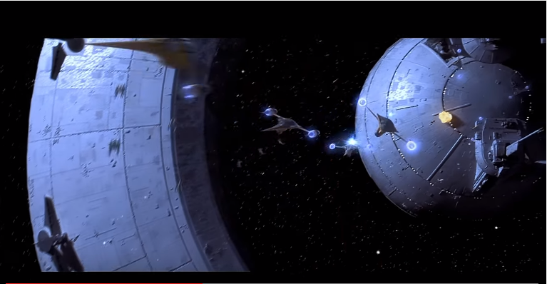

Followed by shot of fighter squadron approaching station from below while rolling in formation. Again some error built into the rate of roll will prevent this from looking particularly robotic.

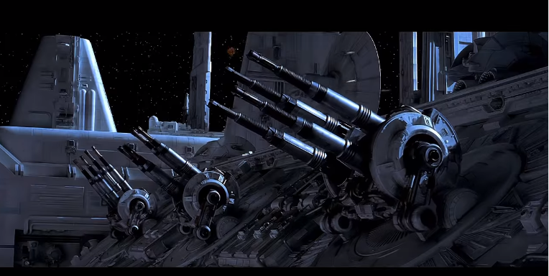

Homemade 3d models for these towers will fire upon an oncoming Starfighter. Destroying one of two approaching craft (below). Particle effects will be used to create the explosion using an emit with an auto-destroy on it.

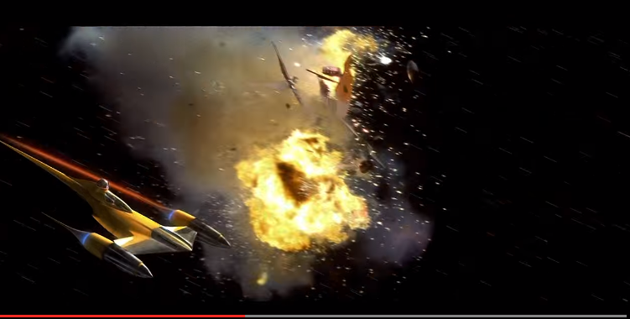

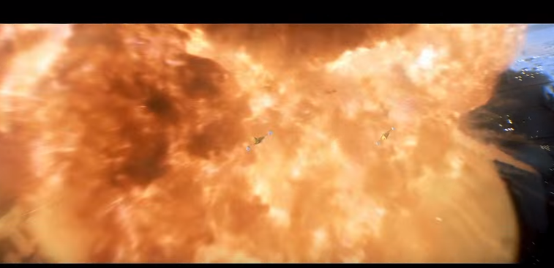

The next shot will show 3 fighters flying into an explosion created in a similar fashion to the previous one, again in formation but rolling at different rates. Before the final shot of a fighter spiralling as it banks into the cargo bay of the space station.

